# 

# **Kinematics Motion Study**

By Fengsheng Zhou, Jinghong Chen, Yihan Shi, Zhihong Li

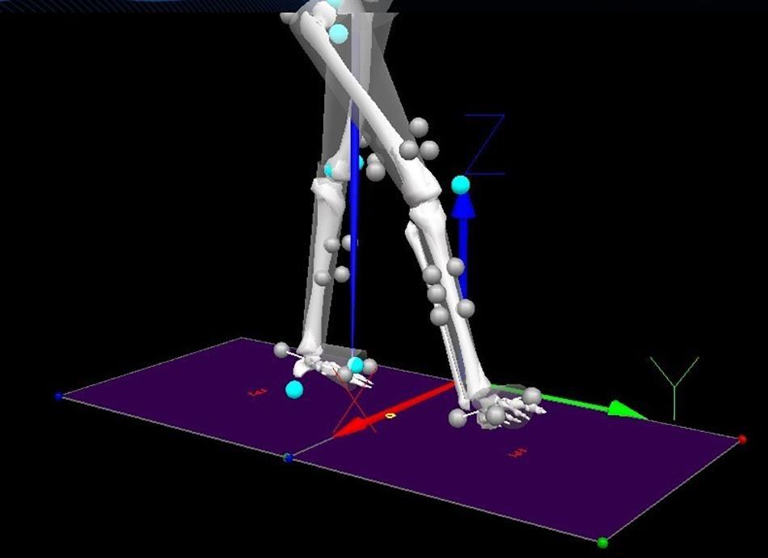

* **Abstract**

From a geometric standpoint, kinematics is a branch of mechanics that does not involve the physical qualities of the item or the force applied to the object in order to describe and study the changing law of the object's position over time. The motion of a deformable body is investigated further based on the research of particle and rigid body motion. To examine the latter's motion, the stiff displacement and strain of the micro-mass in the deformation body must be separated. The motion equation, velocity, acceleration, and other motion characteristics of a point are studied in kinematics. These parameters vary depending on the reference frame chosen, and kinematics must also consider motion properties, such as rotation process, angular velocity, angular acceleration, and so on.

* **Introduction**

Smartphones have an emerging ability to use sensors to measure our physical inputs from outside and convert them into data. There are several kinds of sensors such as Accelerometer, Gyroscope, Magnetometer, Proximity Sensor, and so on. In this project, we will only focus on the two sensors, the Accelerometer and the Gyroscope, which can help us estimate the status of walking or running. How the Accelerometer and Gyroscope measure the data of Acceleration_x, Acceleration_y, Acceleration_z, Gyro_x, Gyro_y, Gyro_z areas in the following pictures. We want to know how the sensors detect the difference between the different statuses and how it might differ when the sensors are in different positions(left or right wrist), additionally explore the dataset as much as we can.

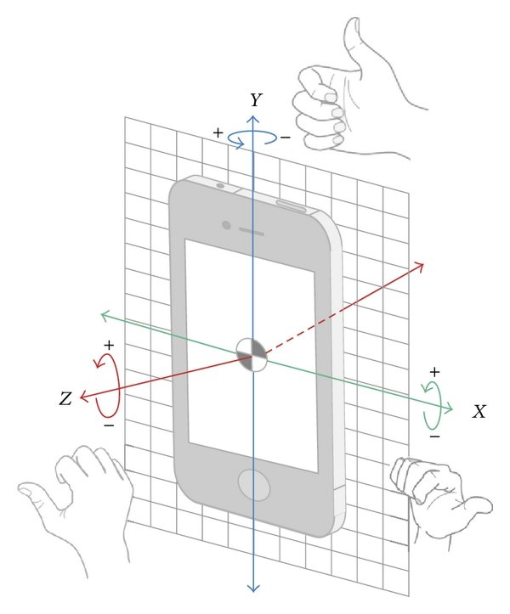

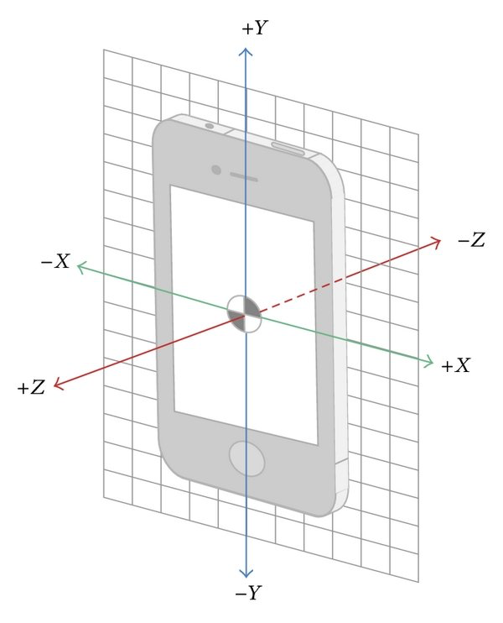

* **Description of the dataset:**

• **Source**

* <https://www.kaggle.com/datasets/yasserh/kinematics-motion-data>.
* Attribute Information:

1. Date
2. Time
3. Username
4. Wrist
5. Activity
6. Acceleration_x
7. Acceleration_y
8. Acceleration_z
9. Gyro_x
10. Gyro_y
11. Gyro_z

• **Preview of the dataset**

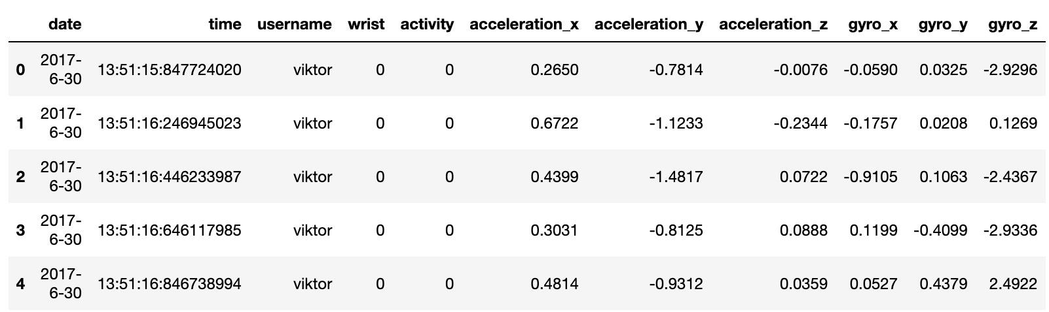

The variables contain date, time, username(viktor),wrist(which side viktor placed his phone on, left when wrist = 0, right when wrist =1), activity(motion status. Walking when activity = 0, running when activity = 1)，accelerations in three directions of accelerometer(X,Y and Z) and angle acceleration in three directions of gyroscope(X,Y and Z).

We first obtain the basic information about the dataset which contains 88588 sensor data samples with no NA value. The absolute max and min of the variables are similar to each other, which means that the accelerations the sensor detected are balanced. Compared to acceleration_y and acceleration_z, acceleration_x has a larger range, and all of the means are around 0. We also observe that the max and min of gyro_x, gyro_y and gyro_z seems abnormal to the data because the 25th empirical percentile and 75th empirical percentile are far away from the values of the min and max values. 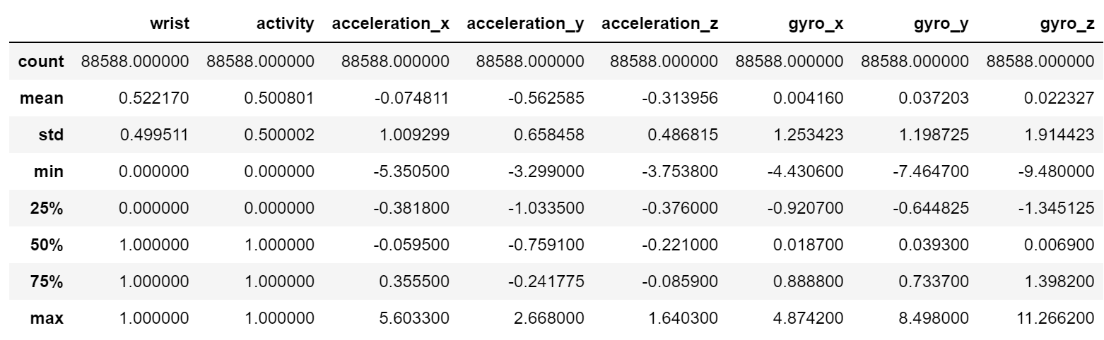

• **Data processing**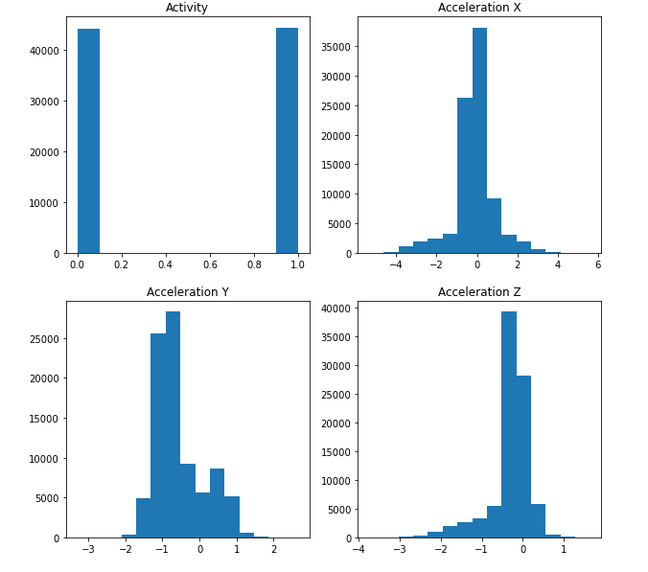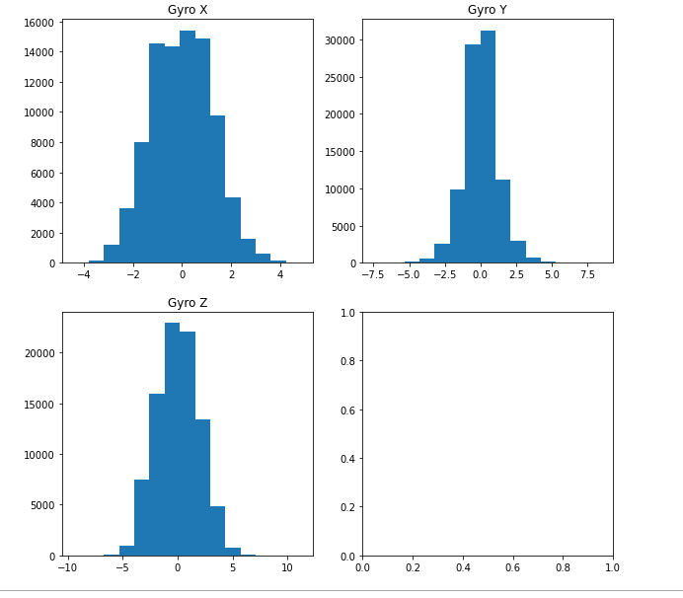

First of all, we checked the distributions of the two motion activities and found out that our dataset has approximately the same samples for both walking and running status, so we do not need to worry about issues caused by imbalanced data. In the histogram of acceleration_x and acceleration_z, we can observe that the data stand around 0, which means that in this dataset, most of the time the person's velocity of X and Z decisions didn't change rapidly. Meanwhile, the data in the histogram of acceleration_y was mostly distributed around -1, since the Y is the longitudinal direction, the negativity could be due to the gravity. On the three gyroscope graphs, we observe that their distribution seems symmetric around 0. Gyro Z has the largest range, gyro X is second and gyro Z is the last. We didn't find much in these graphs.

Next, we further investigate putting acceleration XYZ and gyro XYZ together in 3D plots since they are coordinate correlated.

Accelerations by activities Gyroscopes by activities

Accelerations by wrists Gyroscopes by wrists

The first 3D plot shows the relationship between the motion statuses (walking=purple points, running = yellow points) based on acceleration_x, acceleration_y, and acceleration_z. In this plot, we can clearly see that running and walking data have distant distribution. The running data points spread widely on the plot and walking data points are assembled in the middle of the plot. That shows the clusters of the motion statuses by using accelerations XYZ and we can potentially estimate the statuses by accelerations XYZ.

The second 3D plot shows the relationship between the motion statuses (walking=purple points, running = yellow points) based on the gyro_x, gyro_y, and gyro_z. In this plot, data points for running and walking are not as distinguished from each other as in the first 3D plot. This shows that compared to accelerations, gyroscopes might not be good estimators for the motion statuses.

The third 3D plot shows the relationship between the wrists (left wrist=pink points, right wrist = purple points) based on acceleration_x, acceleration_y, and acceleration_z. In this plot, we can see a clear difference between the two groups of data again. We can clearly observe that the left wrist group and right wrist group clustered on two sides of the plot. Left wrist data points generally have larger X acceleration values and smaller Y and Z acceleration values by comparing them to right wrist data points.

The fourth 3D plot shows the relationship between the wrists (left wrist=pink points, right wrist = purple points) based on the gyro_x, gyro_y, and gyro_z. In this plot,it looks like the left wrist data points are surrounded by the right wrist data points. Both groups of data have similar gyroscope X and Z values, but the right wrist group has a bigger range of gyroscope Y values. The two groups of data have a lot of overlap points, the distribution of gyroscopes for two wrists is not as significantly different as the distribution of the accelerations.

Since there are plenty of points that coincide with each other for all of the 3d contour plots, we may need other methods to separate them.

To continue exploring the relationship between activity, we further use the data from different single directions to plot histograms:

1. Compare the difference between running and walking

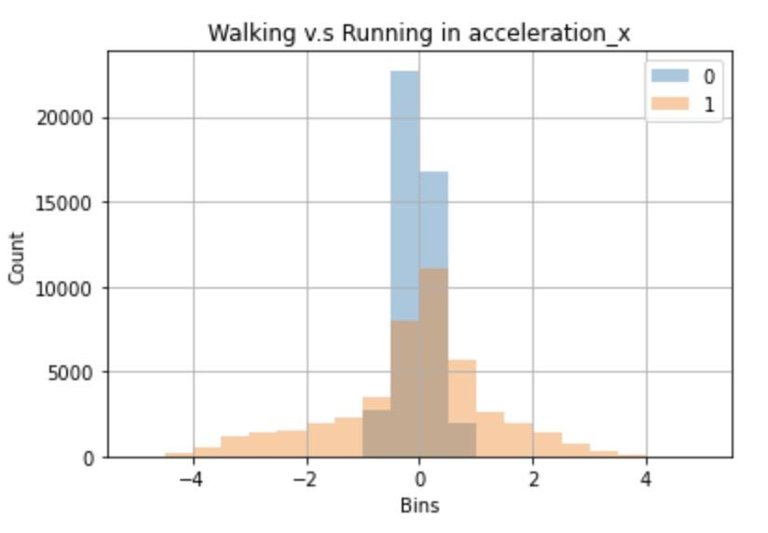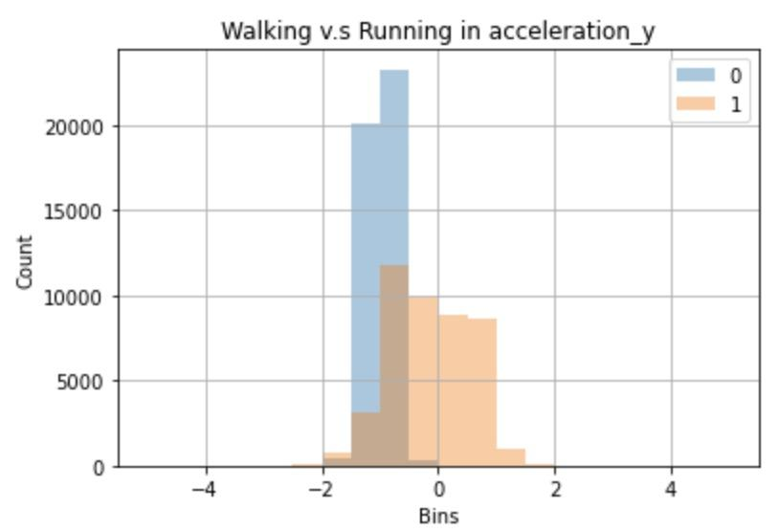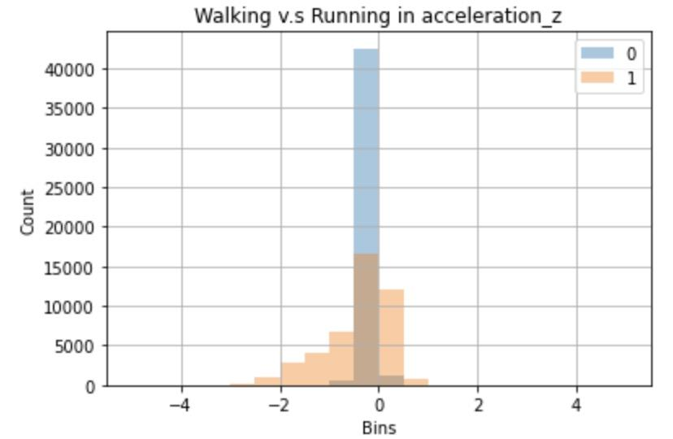

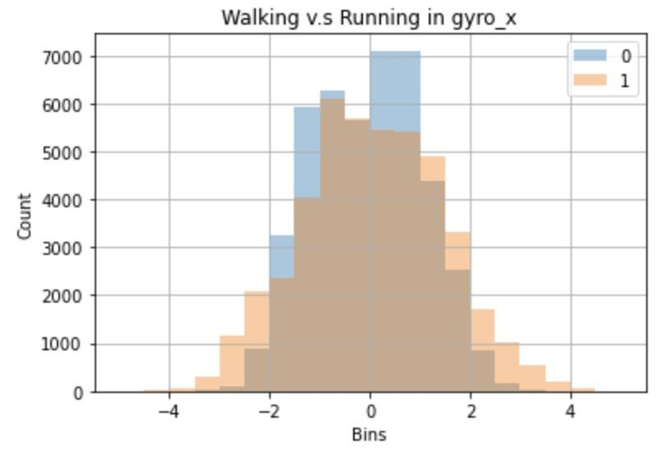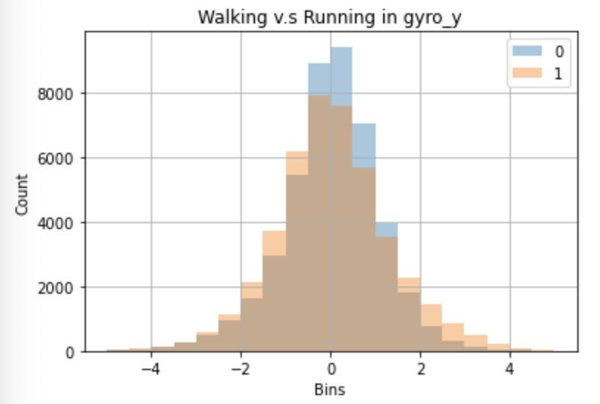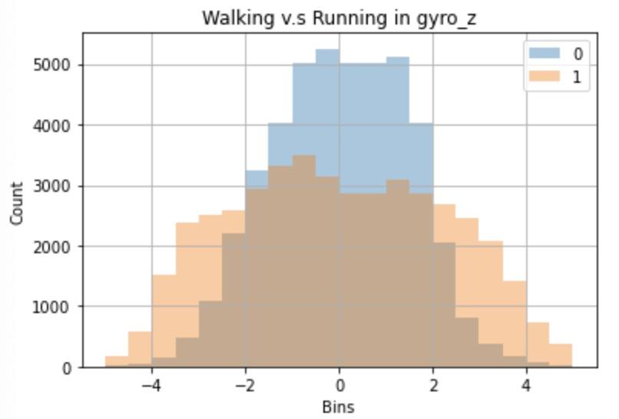

According to the six plots, we can clarify the conclusion that the ranges of running distribution are wider than the walking distribution for acceleration direction or angular velocity in every single direction, especially for acceleration_x. There is a huge difference between walking and running for the acceleration in the x-direction. The distribution of running is more spread out and the range of bins is wider.

Additionally, we find two interesting results:

1. The data for acceleration_y is distributed below 0(could be most of the data because the histogram might omit a little data ), which means that when the person is walking, we can probably consider the acceleration_y is negative.

2. The acceleration_z for running is left-skewed, which somewhat means that the range for the negative acceleration_z is larger than the positive acceleration_z.

Overall, we speculate there is a relationship between the activity and acceleration or angle acceleration.

1. Compare the difference between left and right wrists when running or walking 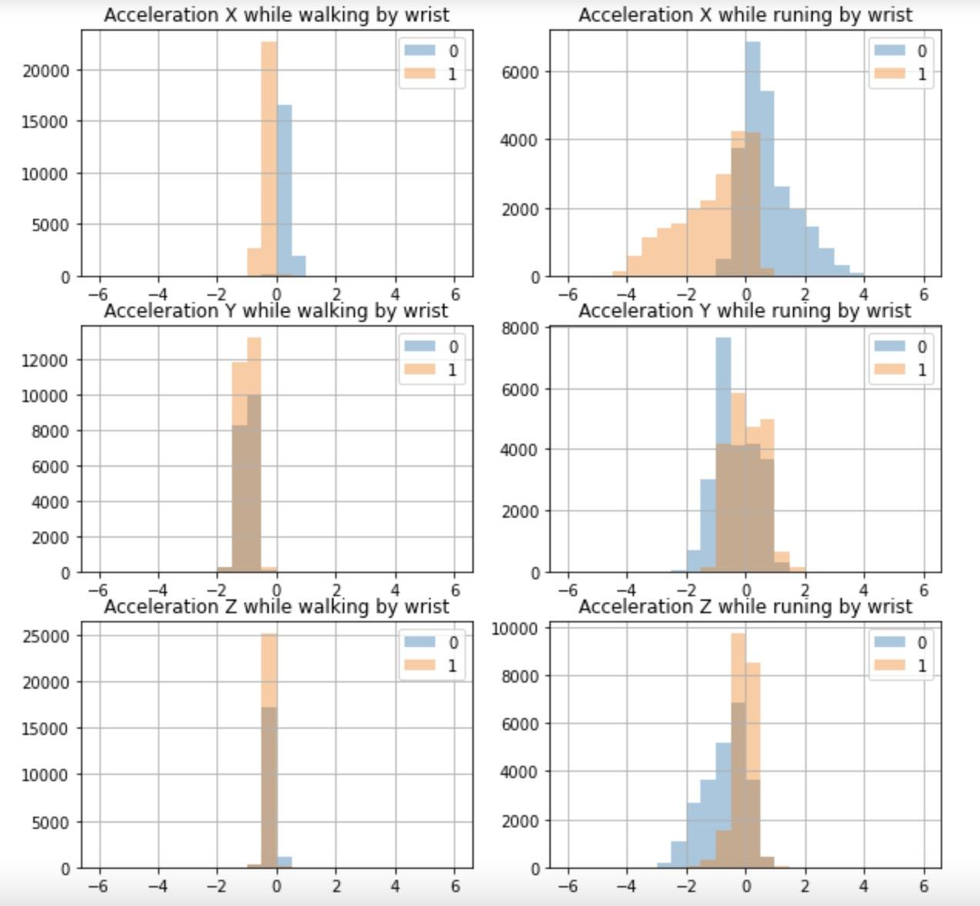

From these histograms, we summarize that in acceleration_x, all the data when walking with a phone on the left wrist is positive and those on the right wrist is negative. When running, although there are some overlaps in the center, the result is similar. And there is no significant discovery for the acceleration_y and acceleration_z. Also, by comparing the two graphs in the same direction, we still find the range of data when running is wider than that of data when walking.

1. Compare the difference between the activity on the same wrist for acceleration_x

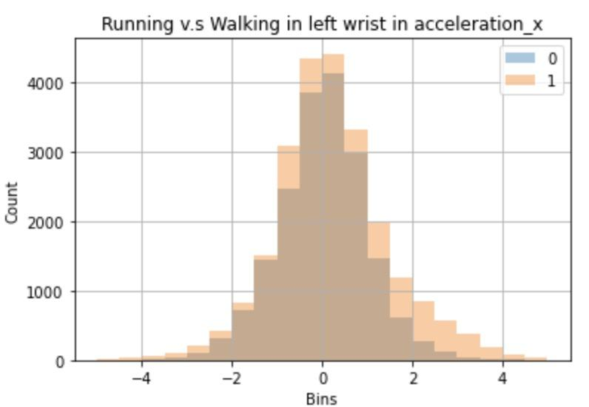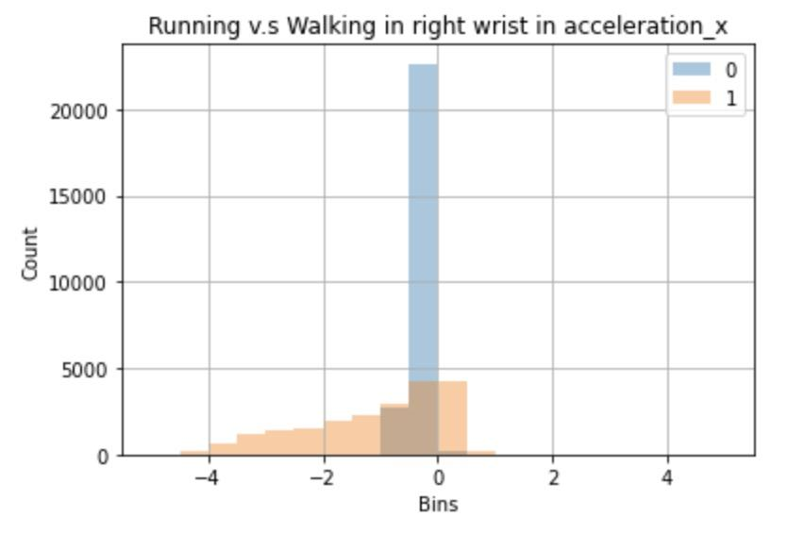

Since we found that how the subject puts his phone has an obvious influence on the result of acceleration_x, we want to explore deeper because the results of acceleration_x may help us tell the wrist. Thus, we plot the histogram for the wrist separately this time.

From these two histograms, we do have a new observation which is that in acceleration_x, there is a huge difference between the running and walking distribution in the right wrist, we can predict that most of the positive data in the right wrist could be predicted as running status. On the other hand, the shape of the running and walking acceleration_x distribution is almost similar in the left wrist, but the running distribution is still a little wider than the walking distribution.

1. Heatmap for acceleration_x when running and walking by wrist

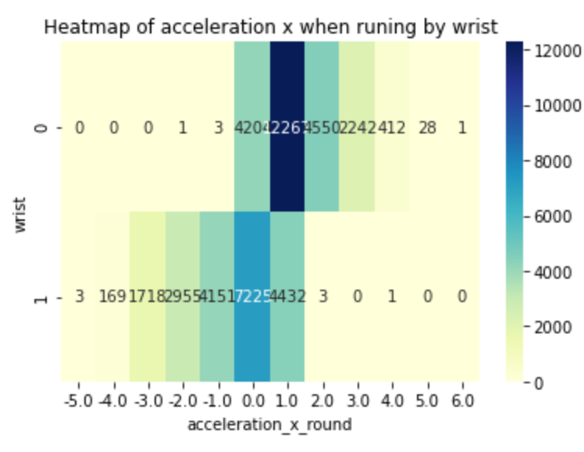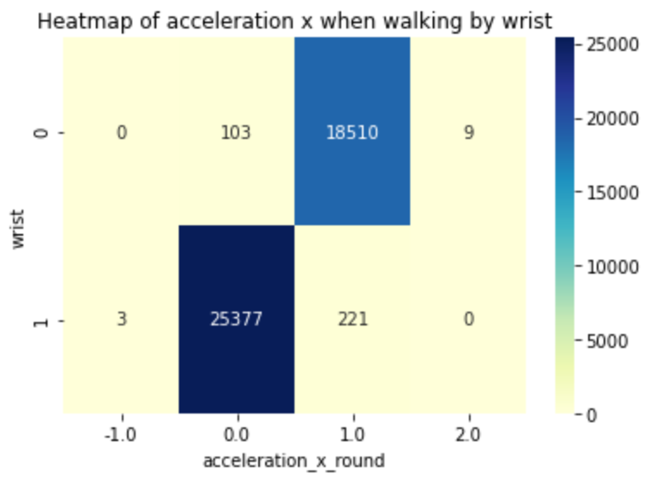

Heatmap proves that the data is more centered in walking but more scattered in running. Also, the conclusion we get is the same as that from histogram: The acceleration_x tends to be positive when walking with a phone on the left wrist and tends to be negative on the right wrist. When running, although there are some overlaps in the center, the result is similar.

* **Contingency Table and Shannon entropy**

using the formulas: $H(x)=-\sum_{i=1}^{n}{}P(x_{i})log_{b}P(x_{i})$

We firstly use the contingency table to know how much observable data is in different wrists and activities. From the table, we know that there is not much difference between the numbers so the sample size won’t affect the conclusion so much. 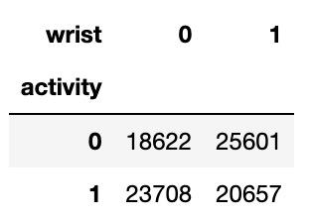

Then we separated them in different ranges in order to calculate the contingency table for each acceleration direction.

From Shannon entropy, by using the data, we can see the certainty of walking/running when acceleration_x, acceleration_y, and acceleration_z in different ranges. The larger Shannon entropy value is, the larger uncertainty we have.

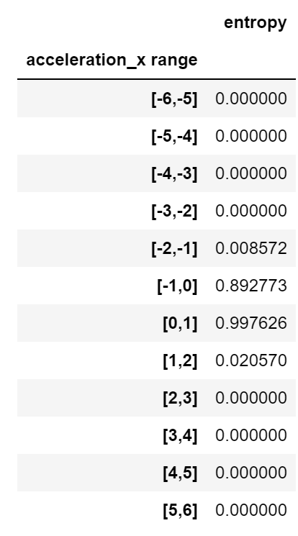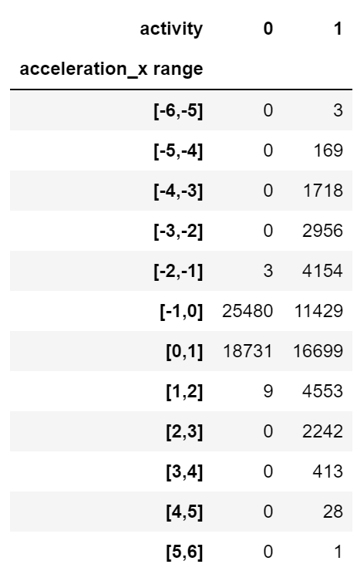

For acceleration_x, we are certain to distinguish between the running and walking when acceleration_x is in the range of [-6, -1] and [1,6].In contrast, it is hard to separate the activity in the range of [-1,1].

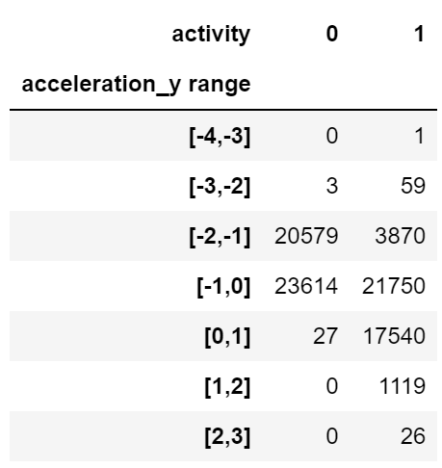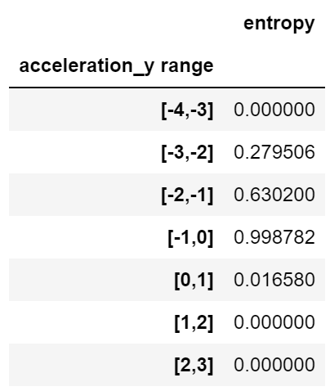

For acceleration_y, we have more confidence to know the activity type when acceleration_y is in the range of [-4,-3] and [0,3], However, we can’t make sure data is recorded when running or walking in the range of [-3,0], .

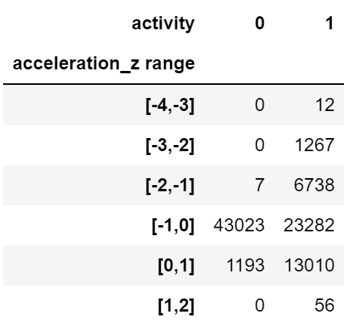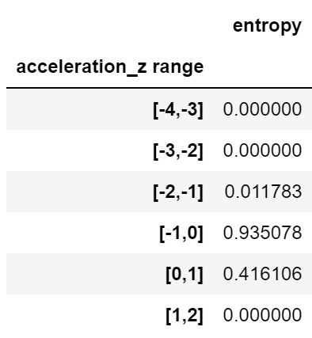

For acceleration_z, we can distinguish the activity types when the number is in [-4,-1] and [1,2], while in [-1,1], it is kind of difficult to separate.

* **Time Series Plots for Accelerations**

Since acceleration_x presents us with more information about the data, we draw the time series plot in acceleration_x by activities and wrist separately to further explore the data.

-Blue part: walking

-Orange part: running

-Pink part: left wrist

-Purple part: right wrist

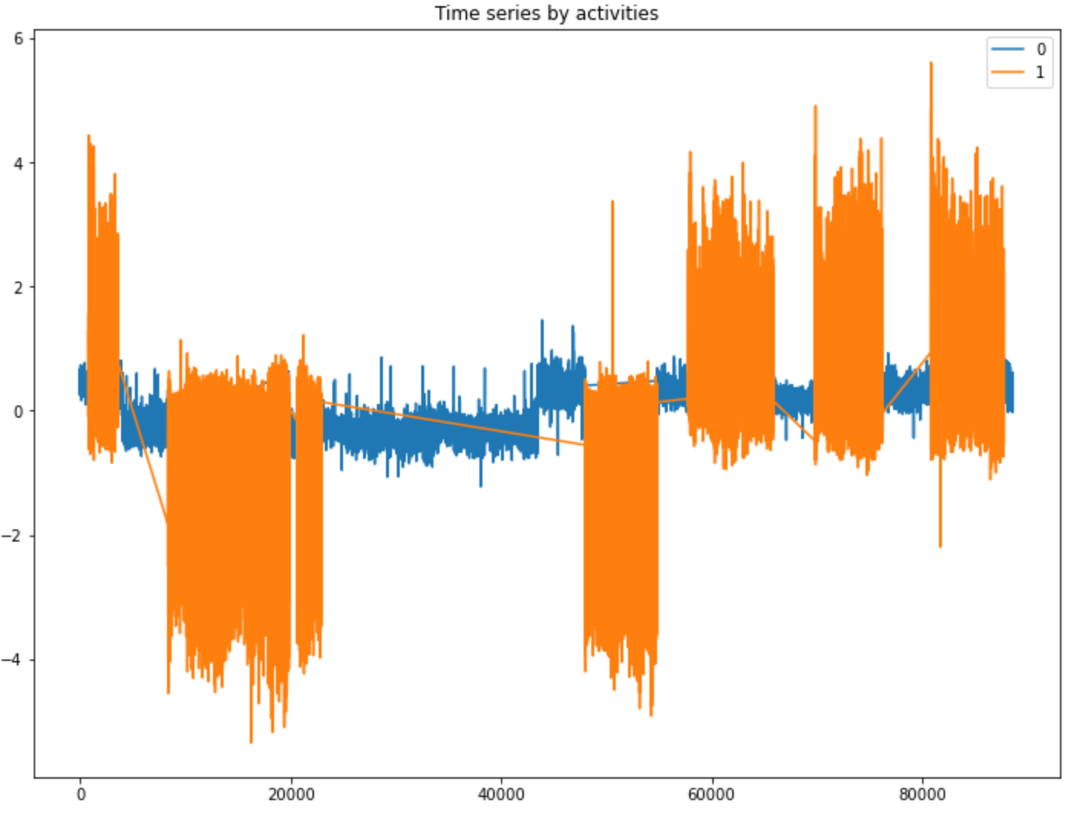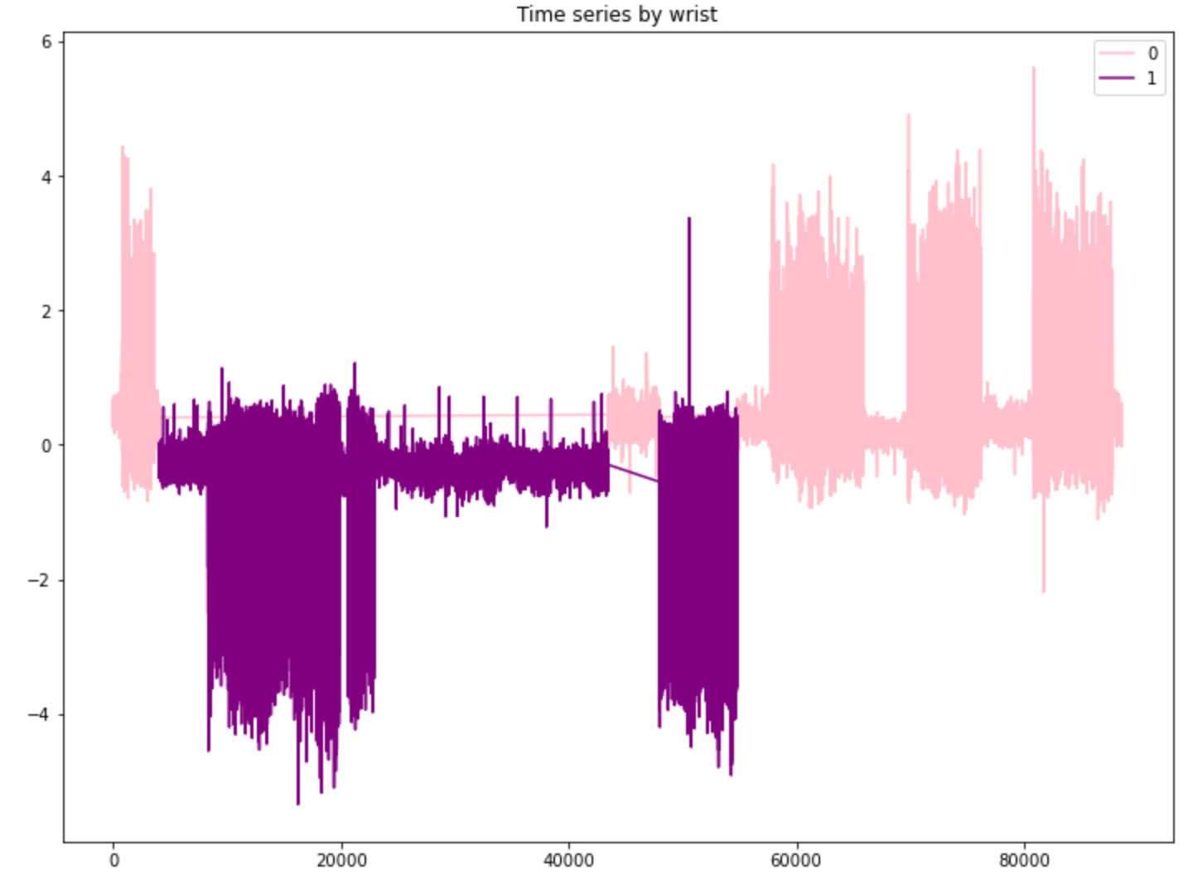

From the first plot, it is clear that the fluctuation of the orange part (running) is much wider than that of the blue part (walking). We can speculate that when running the fluctuations are wider; on the other hand, when walking, the fluctuations are more stable.

From the second plot, we can observe that most of the pink part(left wrist) is positive while most purple part (right wrist) is negative with few exceptions. This indicates that when the phone was put in the left wrist, the angle acceleration detected by the sensor is usually positive, and when the phone was put in the right wrist, the angle acceleration detected by the sensor is usually negative instead.

In this part, in order to find some rhythm for the data, we only take the first 200 samples to see the fluctuation of each acceleration with the phone in the left wrist when walking.

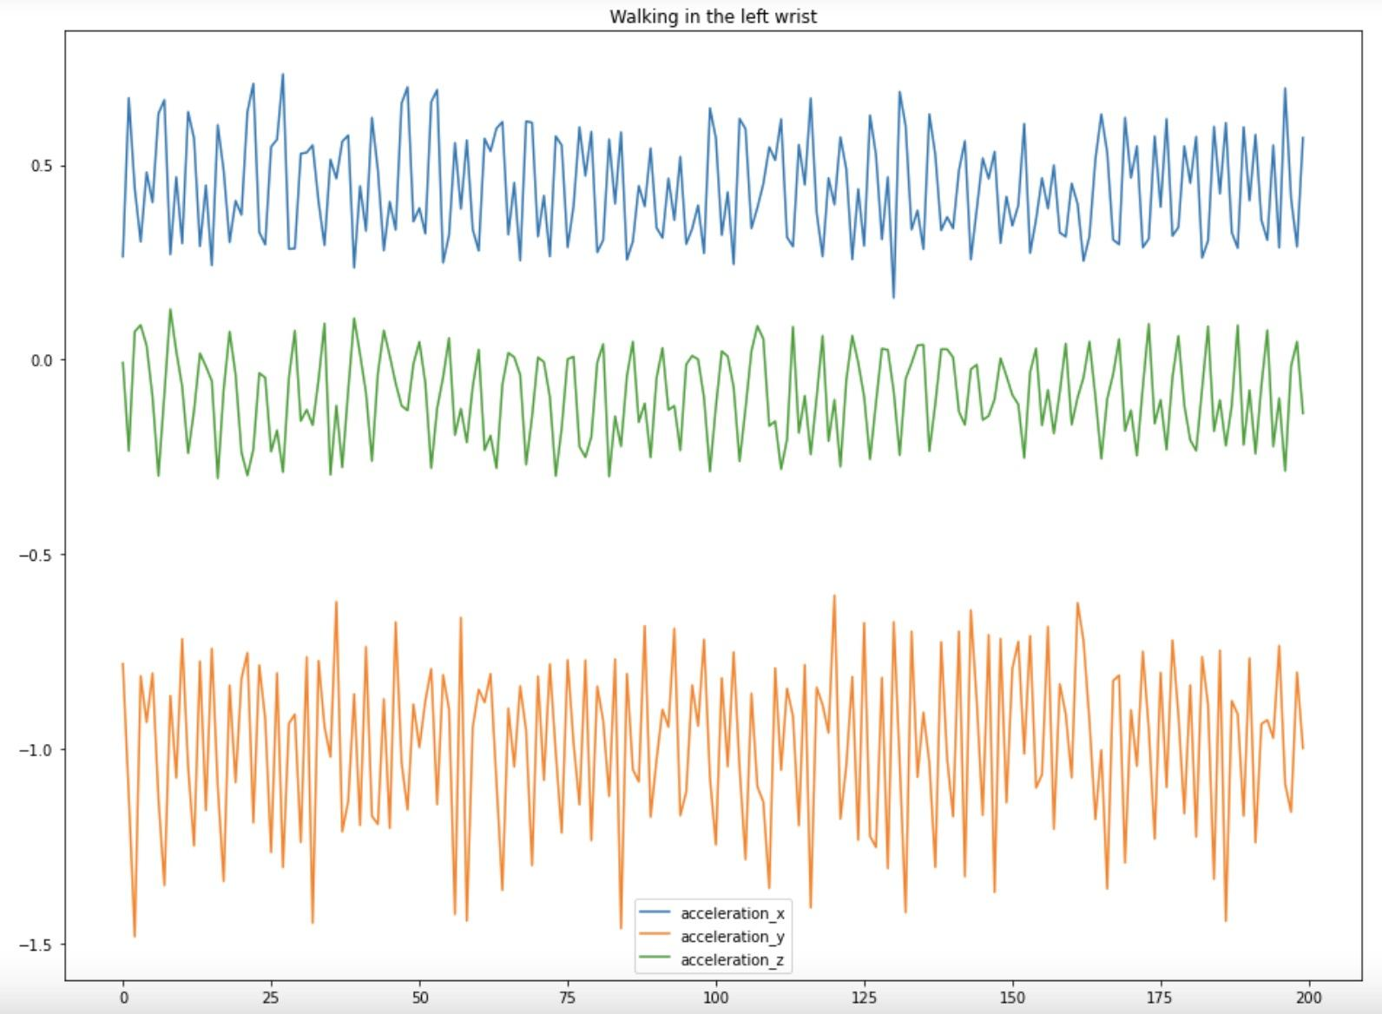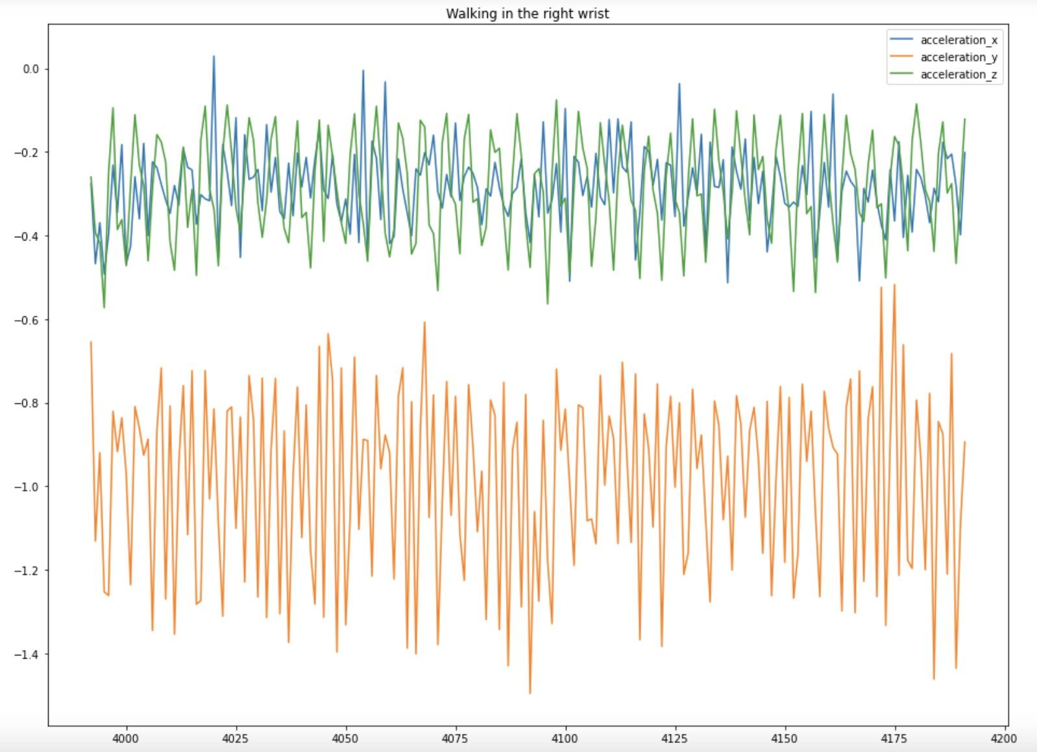

1a 1b

The result from 1a plot represents the three findings below:

1. There is no intersection in each direction of acceleration.
2. When the blue line (acceleration_x) is going to reach peak, the green (acceleration_y) and orange line (acceleration_z) is going to reach trough. When the blue line is going to reach trough, the green and orange line is going to reach peak. To sum up, the trend of acceleration_x is totally contrast to that of acceleration_y and z and the trends of acceleration_y and z are the same.
3. The fluctuation of acceleration_z is larger than that of acceleration_x and y, while x and y are similar.

Next, by using the 200 samples, we continue plotting the fluctuation plot with the phone in the right wrist when walking.

The result from the 1b plot represents the three findings below.

1. The fluctuations of acceleration_x and y overlap, which is super different from the first plot (in the left wrist when walking).
2. The trend of the accelerations seem the same in most situations. When the orange line (acceleration_z) is going to reach its peak, the blue line (acceleration_x) and green line (acceleration_y) are going to reach their peaks. When the orange line is going to reach the trough, the blue line and green line is going to reach the trough. To sum up, the trend of acceleration_x, acceleration_y and acceleration_z are similar.
3. The fluctuation of acceleration_z is larger than that of acceleration_x and acceleration_y while the fluctuations of acceleration_x and acceleration_y are similar.

We did the same thing and found the symmetric relationship of fluctuation in acceleration when running between the left and right wrist.

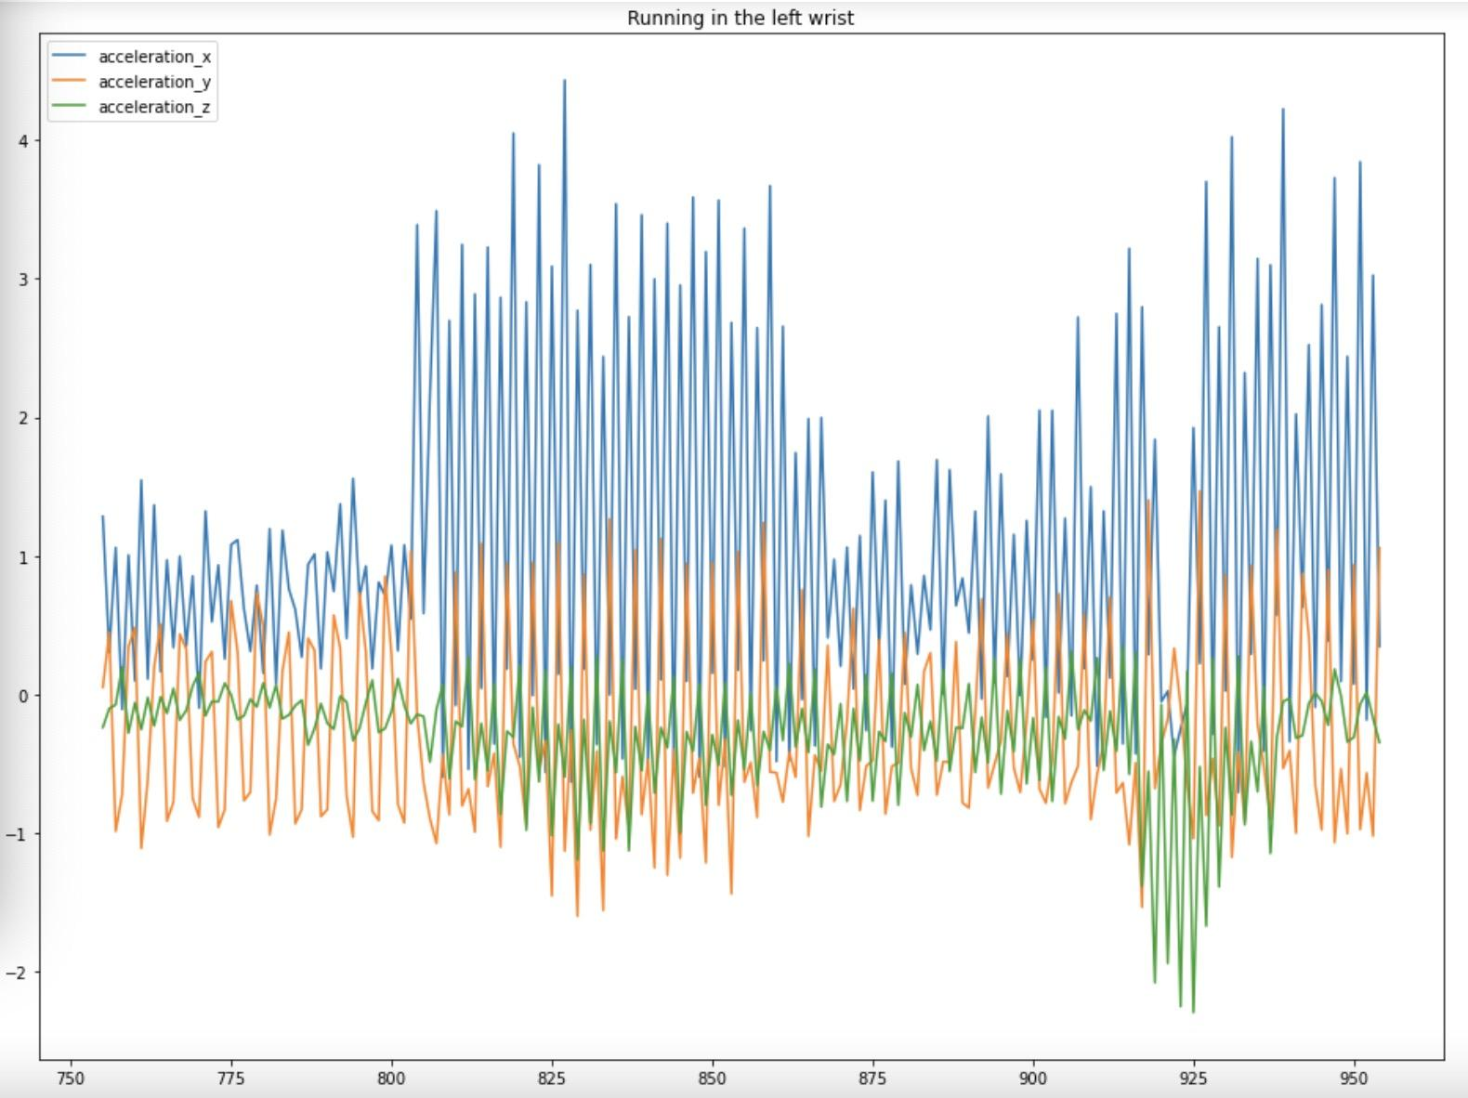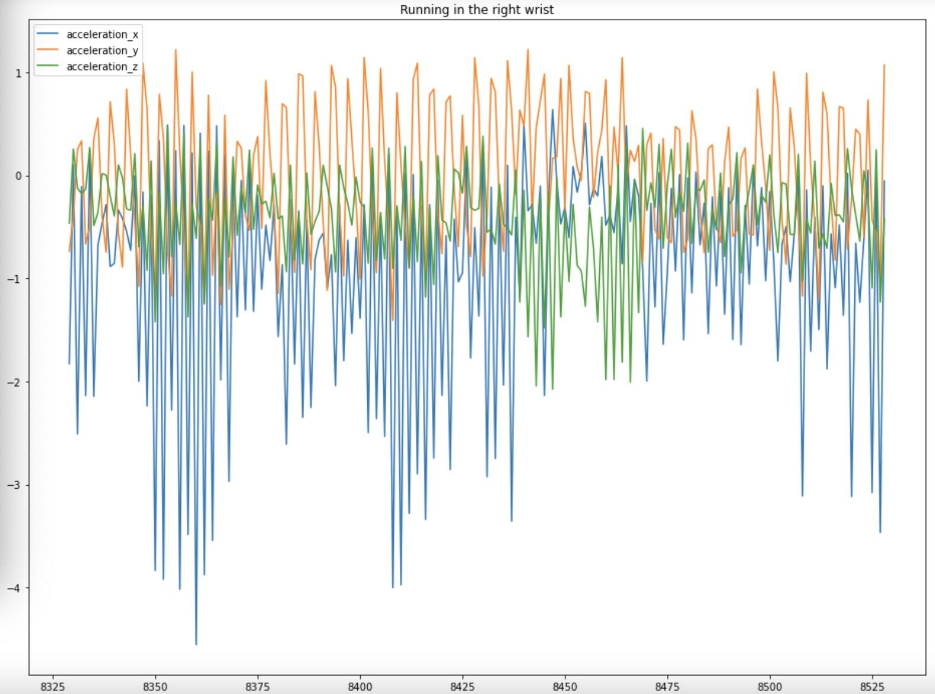

2a 2b

Comparing the plot 2a and 2b, we find some relationships below.

1. From 2a (walking in left wrist), when the blue line (acceleration_x) is going to reach peak, the green (acceleration_y) and orange line (acceleration_z) is going to reach trough. When the blue line is going to reach trough, the green and orange line is going to reach peak. To sum up, the trend of acceleration_x is totally contrast to that of acceleration_y and z and the trends of acceleration_y and z are the same. However it is unstable, sometimes when the blue line is going to reach peak the green line is going to trough but the orange line is going to reach peak.--- This result is similar but more stable when walking on the left wrist.
2. From 2b (walking in the right wrist), when the orange line (acceleration_z) is going to reach peak, the blue line (acceleration_x) and green line (acceleration_y) is going to reach peak. When the orange line is going to reach the trough, the blue line and green line are going to reach the trough. However, again the result might not be stable, we still need to pay attention to the exception. To sum up, the trends of acceleration_x, acceleration_y and acceleration_z are similar. --- This result is similar but more stable when walking on the right wrist.
3. For both plots, the fluctuation of acceleration_x is wider than that in the other two directions. And most of the three colors are overlapping.

In summary, whenever walking or running, if the phone is on the left wrist, the trend of acceleration_x is totally contrasted to that of acceleration_y and z. In the right wrist, the trends of acceleration_x, acceleration_y and acceleration_z are similar. Even though the results when running might be unstable, the overall trends stay still. Additionally, we found that when walking acceleration_x and acceleration_y are always separated, and acceleration_x and acceleration_z are overlapping when it is on the right wrist. While running, the three accelerations overlap together.

Since the conclusion comes from a detailed fluctuation plot, we still need to find the overall distribution of the accelerations.

* **Cat plot for accelerations**

In order to find the overall distribution of the accelerations; therefore, we draw the cat plot for both of them in different categories.

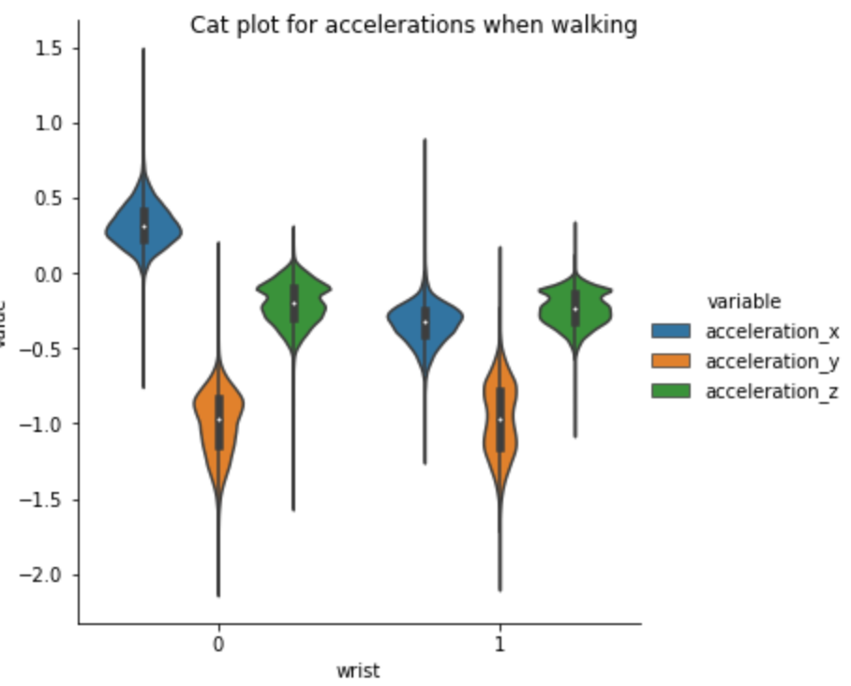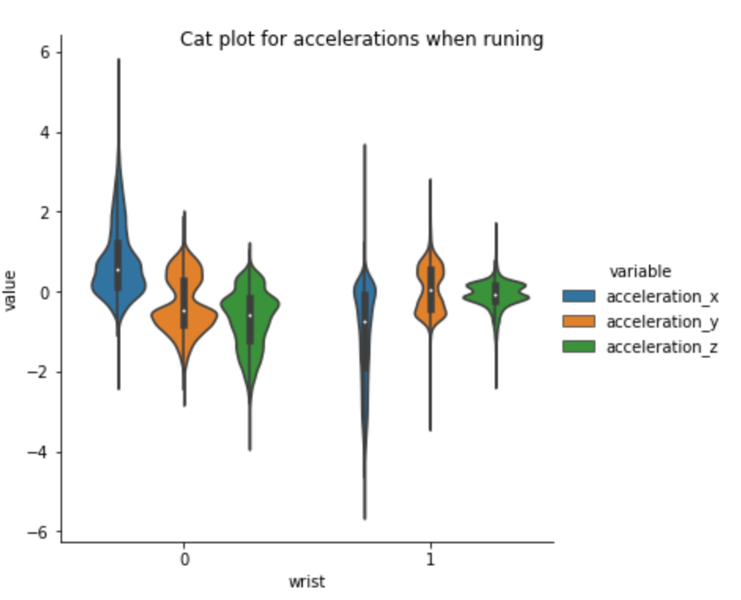

3a 3b

From 3a (catplot for accelerations when walking), we find that except for the outlier,the distributions of every direction in the left wrist are all separated. While in the right wrist, the blue (acceleration_y) and green (acceleration_z) overlap mostly. But, the blue (acceleration_y) and green (acceleration_z) are still separated from the orange (acceleration_x).

From 3b (catplot for accelerations when running), we find that almost all directions overlap whenever in the left or right wrist when running.

* **The Time Series Plot for Gyroscope**

In the way of a gyroscope, we also use the first 200 samples to compare the fluctuation between left and right wrist when being in the same activity.

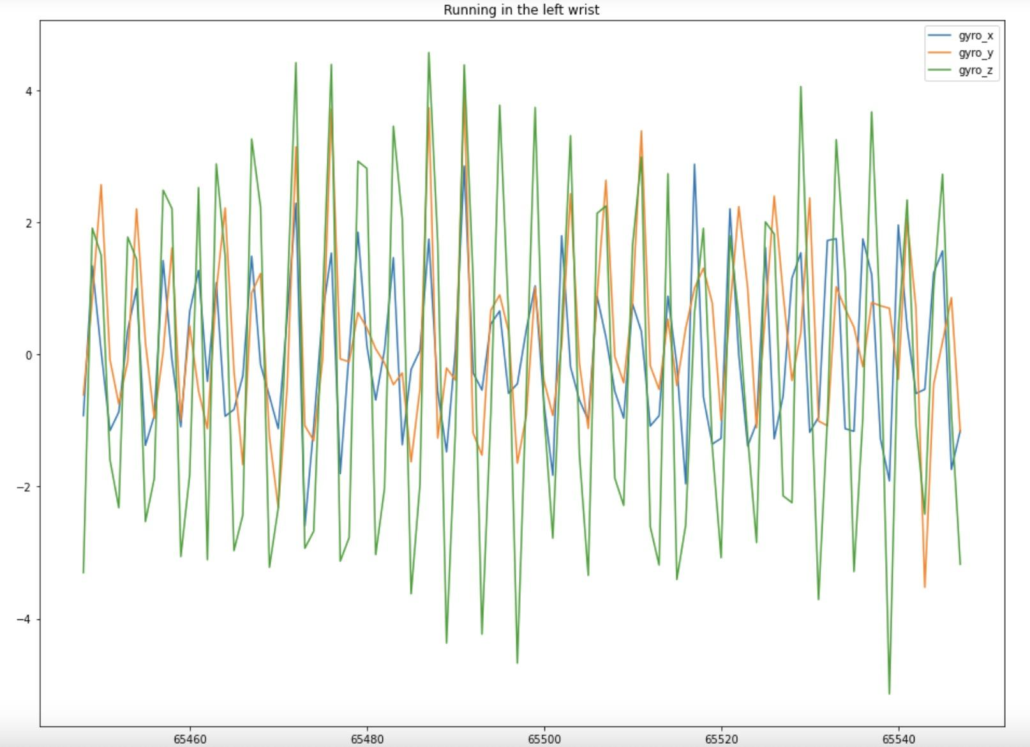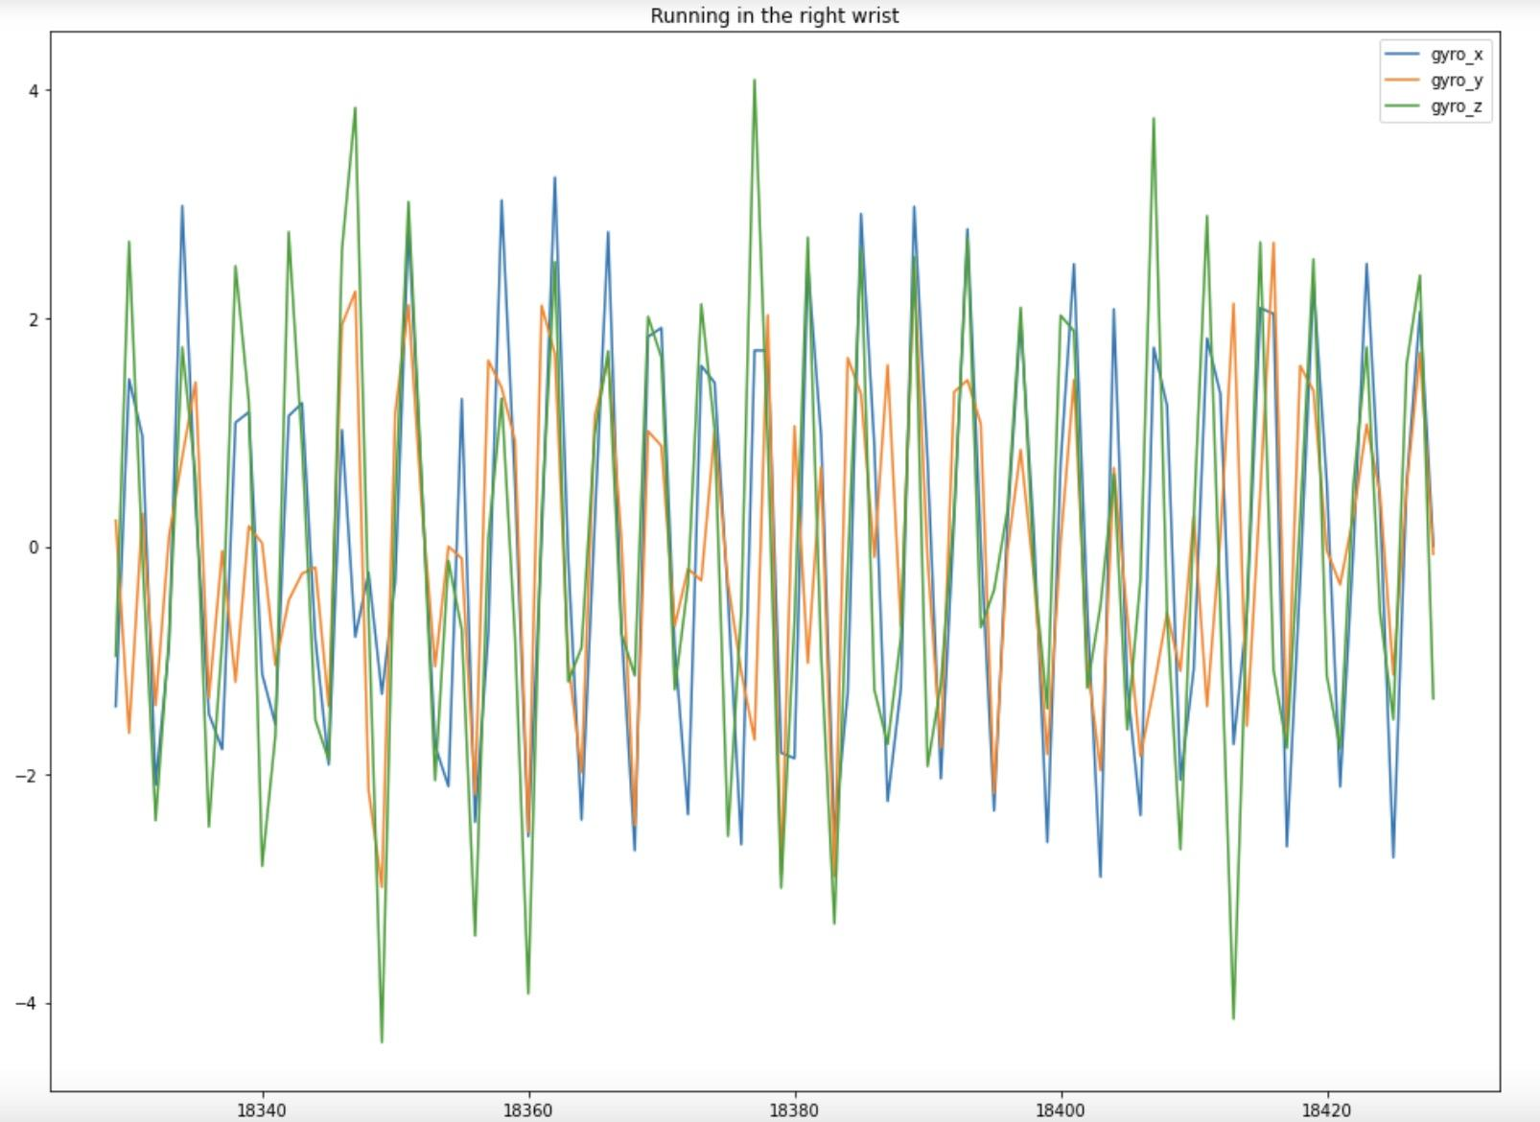

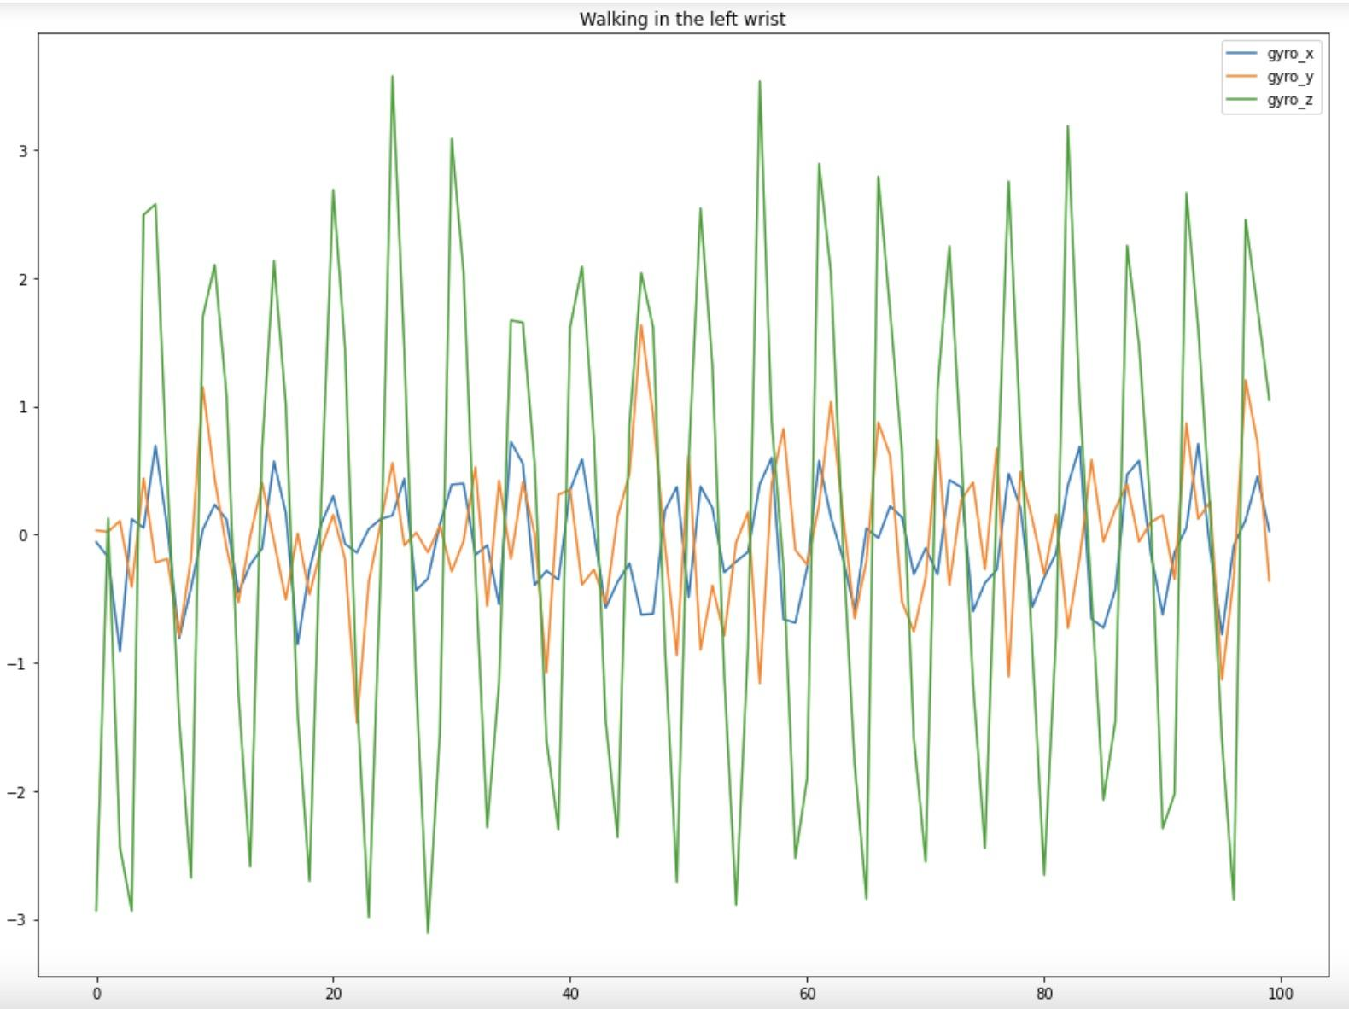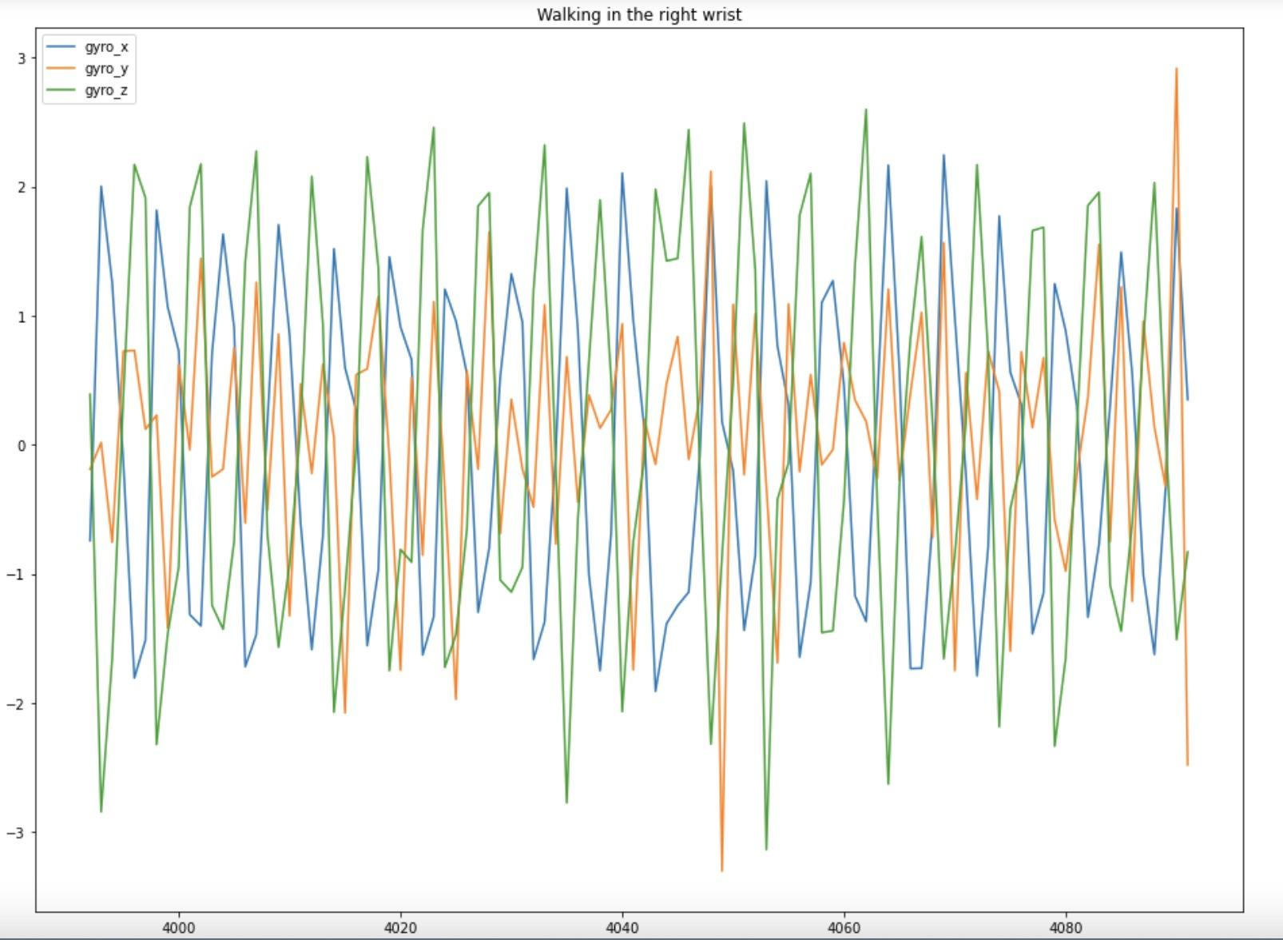

When walking, there are two clear rules we found.

1. When walking in the left wrist, the fluctuation of gyro_x is significantly wider than other directions. Also, this kind of difference is cleared when walking in the right wrist, meaning that when walking in the right wrist, the gyro_y and z fluctuate larger than walking in the left wrist.
2. In the way of trend, all plots show the same trend except for walking in the right wrist. When the blue line (gyro_x) is going to reach peak, the green (gyro_z) and orange line (gyro_y) is going to reach trough. When the blue line is going to reach trough, the green and orange line is going to reach peak. To sum up, the trend of gyro_x is totally contrast to that of gyro_y and z and the trends of gyro_y and z are the same. -- This result is similar to the acceleration when walking on the right wrist.

However, according to these plots, we find that when running, all the trends of all gyroscopes are the same and the fluctuations of all directions are similar whenever it is in the left or right wrist, which proves that there is not much difference in gyroscopes when running.

* **Catplot for Gyroscope**

Although the detailed fluctuation does not give us too much surprising information, we plot the catplot as usual.

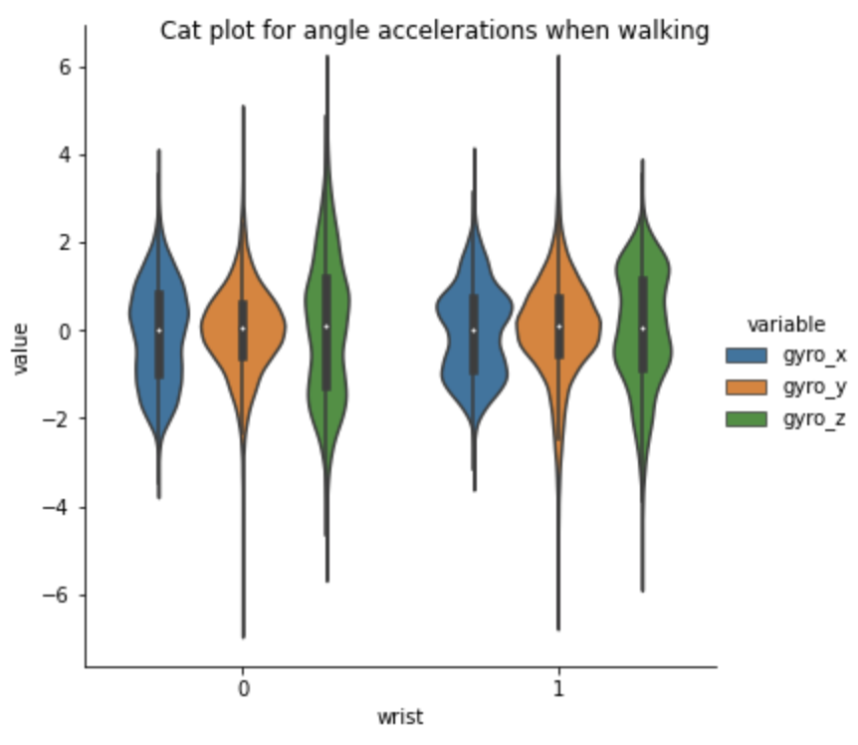 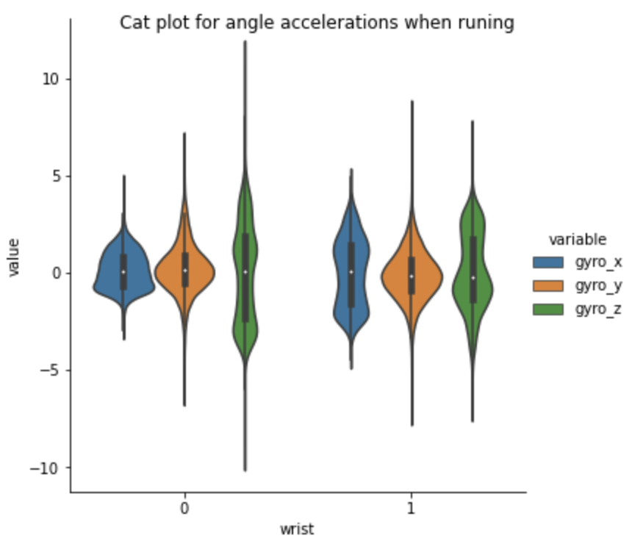

4a 4b

As we expected, there is no significance found in these plots. All the angle accelerations in three directions overlap together.

* **Magnitude**

Due to the result drawn from the plots of accelerations, it is clear that the fluctuation of running is far bigger than that of walking, so we use the formulas below to calculate the magnitude and plot so that we could distinguish them more. $|v_{i}|=\sqrt{((x_{i}-x_{i-1})^{2}+(y_{i}-y_{i-1})^{2}+(z_{i}-z_{i-1})^{2}}$

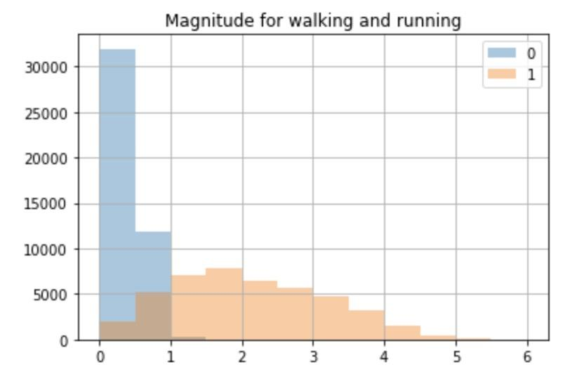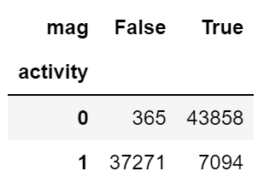

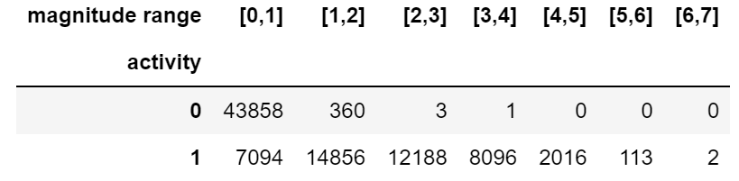

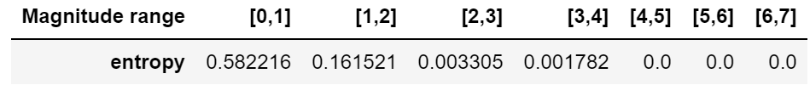

By calculating the bounded magnitude (using 1), we test the correct rate of this method. Although there is some wrong data, the successful probability for magnitude is all up to 90%. We can see how high successful predictions are when the magnitude range is in [2,7].

Therefore by plotting the contingency table and generating Shannon entropy table, now we have enough confidence to distinguish the motion status.

* **HC Tree with method ward:**

Using function: $D_{kL}=B_{KL}=\frac{||\underline{x_{k}}-\underline{x_{L}}||}{\frac{1}{N_{K}}+\frac{1}{N_{L}}}$

From the previous exploration, activities and wrists seem to congregate into distinct groups when we plot it by acceleration XYZ. We can use the Hierarchical Cluster Tree to find out if the cluster exists. Hierarchical Cluster Tree works from the bottom-up and continues paired groups that are close distance to each other until we are done with the whole data. We choose Ward's minimum variance method to calculate the distance of the data point to find the closest pairs.

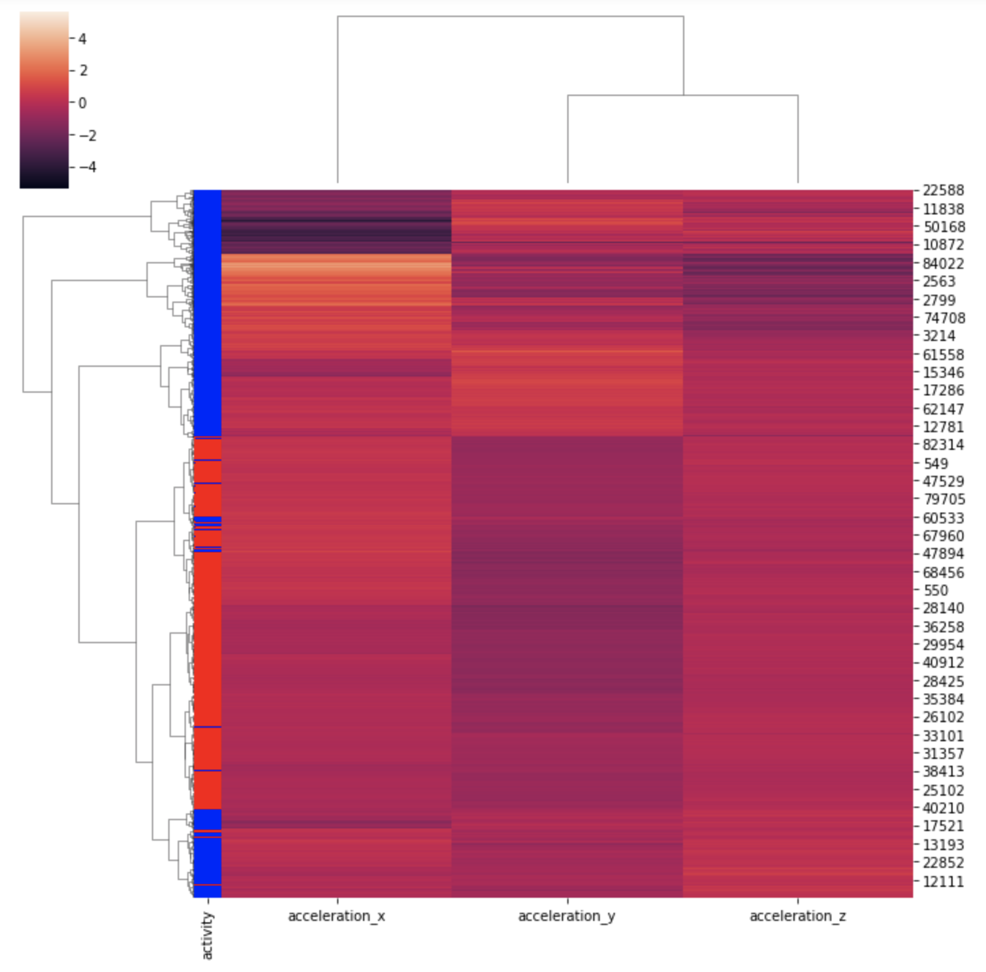

In this plot, we can see running has two clusters, one on the top and one on the bottom. And walking mostly lies in the middle. Only a few data points were misgrouped. Thus, by using accelerations XYZ, we can accurately differentiate two activities groups. One interesting thing we find is that running data was divided into two groups and estranged from each other. From the tree on top of the plot, we can also see acceleration Y and Z are more closely related to one another than acceleration X.

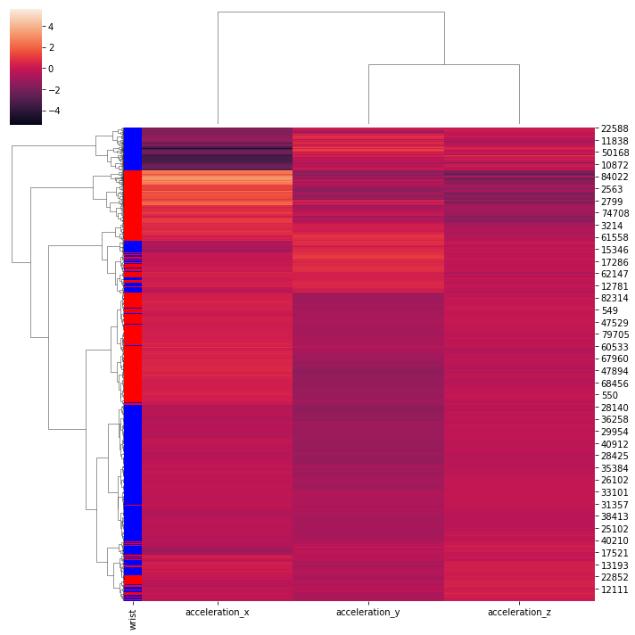

In this plot, we can see the right wrist has two clusters too, one on the top and one on the bottom. And the left wrist mostly lies in the middle. Compared to the activities, the wrist has more miss grouped data points. Compared to activity clusters, wrist clusters are more inaccurate. From the tree on top of the plot, we can also see in this clustering that acceleration Y and Z are more closely related to one another than acceleration X.

* **Conclusion:**

In the whole project, we want to explore the relationship between the different activity statuses (walking or running) and different positions (left or right wrist). Firstly, by organizing the data and drawing 3D and Histogram charts, we have a simple conclusion that running data is more spread out and data when walking is more central. However, it is hard to find the relationship between the acceleration & gyroscope and wrist.

Then, we respectively studied the difference of acceleration and angular velocity in walking and running in each direction, and the difference of sensor in left wrist and right wrist in the same activity state. From the results, we can only conclude that in acceleration_x, most left wrist movements with the phone are positive, and all right wrist movements with the phone are negative. Thus, we further analyze the X direction and compare the difference between the activity on the same wrist. We found a significant difference between running and walking on the right hand, but very little difference on the left hand, which is too wired to convince us.

Next, we prepared the Contingency Table and calculated the Shannon Entropy to get the range of data that we were sure of activity in each direction. Also, the fluctuation plot for acceleration_x helps us to ensure that the bigger fluctuation is more likely as the data when running and the positive part is more likely as the data when the sensor is in the right wrist. On the contrary, the smaller fluctuation is more likely as the data when walking and the negative part is more likely as the data when the sensor is in the left wrist.

Furthermore, acceleration_x has the opposite trend to acceleration_y and Z when the phone is on the left wrist while walking or running. On the right wrist, acceleration_x, acceleration_y, and acceleration_z have similar trends. While the results may be erratic while running, the overall trend remains the same. We examined the fluctuations of acceleration and angular velocity under different motion states or sensor positions and found some rules, which are proved by catplots. Besides, it is more clear to distinguish the fluctuation of running and working by magnitude Plot and we have 90% confidence to judge the activity states.

Finally, HC illustrates that running data and right wrist data are divided into two groups and estranged from each other. Also, acceleration Y and Z are more closely related to one another than acceleration X whenever by activities or wrists.

From the whole process, it is easy to find that for any direction of acceleration or angular velocity, the fluctuation is always greater when running than when walking. This seems to make sense because when running, both the range of motion and speed increase, leading to an increase in acceleration and angular velocity.

Also, we find an amazing conclusion that when the phone is on the right wrist, the range of acceleration and angular velocity will be wider on the left wrist when the author is doing the same activity. Thus, we guess that for most people, the right leg is the dominant leg so that people will use more power from their right legs, leading to the larger amplitude of the right foot.

However, there are still many uncertainties in the data collection process. For example, the author did not place the left and right sensors at the same time, which may lead to certain errors. We also don't know for sure if the road is smooth enough in the whole experiment. Maybe in the future, we can present more comprehensive research with more information.